## Automated ELK Stack Deployment

The files in this repository were used to configure the network depicted below.

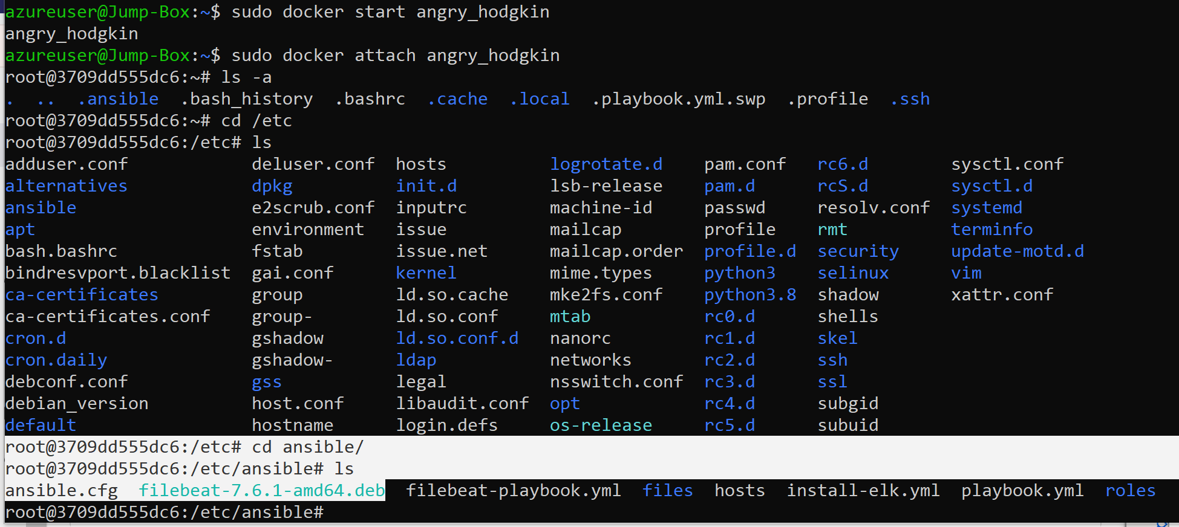

**![TODO: Update the path with the name of your diagram](Images/diagram_filename.png)**

**These files have been tested and used to generate a live ELK deployment on Azure. They can be used to either recreate the entire deployment pictured above. Alternatively, select portions of the _____ file may be used to install only certain pieces of it, such as Filebeat.**

- _TODO: Enter the playbook file._

This document contains the following details:

- Description of the Topologu

- Access Policies

- ELK Configuration

- Beats in Use

- Machines Being Monitored

- How to Use the Ansible Build

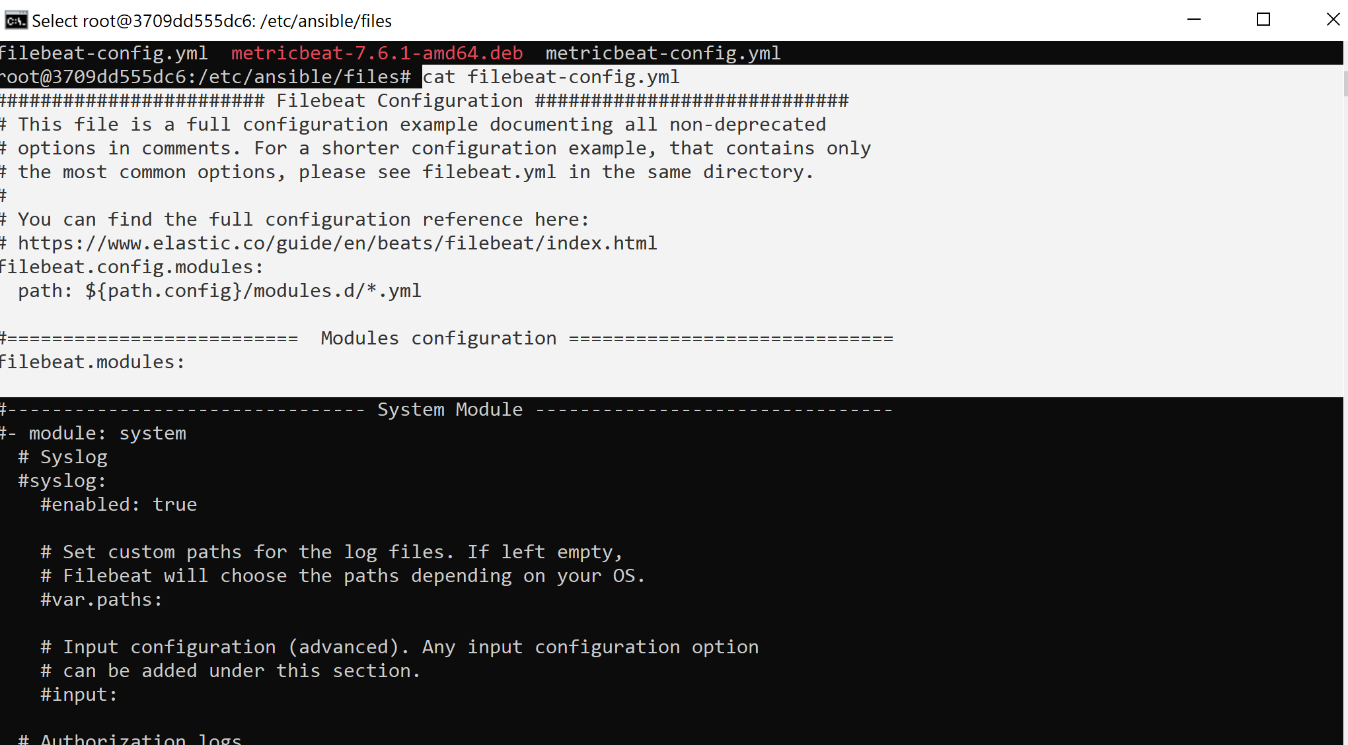

### Description of the Topology

The main purpose of this network is to expose a load-balanced and monitored instance of DVWA, the D*mn Vulnerable Web Application.

Load balancing ensures that the application will be highly **_efficient** ____, in addition to restricting __**availability_**__ to the network.

- _TODO: What aspect of security do load balancers protect? What is the advantage of a jump box?_**In the cloud infrastructure load balancers help protect against DDoS attacks. Benefits of the Jump Box VM is that it is secure and you must connect to it before launching administrative tasks. Also it acts as an audit within the DMZ where we can manage user accounts.**

Integrating an ELK server allows users to easily monitor the vulnerable VMs for changes to the ___**data**__ and system _**logs_**___.

- _TODO: What does Filebeat watch for?_ **It monitors the log files or locations that you specify, collects logs events and forwards them to Elasticsearch for indexing.**

- _TODO: What does Metricbeat record?_ **It takes the metrics and statistics that it collects and ships them into an output that you specify in Elasticsearch. Also helps monitor servers with Apache.**

The configuration details of each machine may be found below.

_Note: Use the [Markdown Table Generator](http://www.tablesgenerator.com/markdown_tables) to add/remove values from the table_.

| Name | Function | IP Address | Operating System |

|----------|----------|------------|------------------|

| Jump Box | Gateway | 10.0.0.1 | Linux |

| ELKvm | SIEM | 10.1.0.4 Linux | |

| web-1 | VM | 10.0.0.4 | Linux |

| web-2 | VM | 10.0.0.5| Linux |

### Access Policies

The machines on the internal network are not exposed to the public Internet.

Only the _**_Jump-Box_**_ machine can accept connections from the Internet. Access to this machine is only allowed from the following IP addresses:

- _TODO: Add whitelisted IP addresses_  **76.86.220.247**

Machines within the network can only be accessed by _**_Jump-Box**___.

- _TODO: Which machine did you allow to access your ELK VM? What was its IP address?_**Jump-Box 20.124.242.7**

A summary of the access policies in place can be found in the table below.

| Name | Publicly Accessible | Allowed IP Addresses |

|----------|---------------------|----------------------|

| Jump Box | Yes/No | 10.0.0.1 10.0.0.2 |

| | | |

| | | |

### Elk Configuration

Ansible was used to automate configuration of the ELK machine. No configuration was performed manually, which is advantageous because...

- _TODO: What is the main advantage of automating configuration with Ansible?_**Midigates human error from repetitive tasks.**

The playbook implements the following tasks:

- _TODO: In 3-5 bullets, explain the steps of the ELK installation play. E.g., install Docker; download image; etc._

* Create Elk VM and NSG
* Peer connect ELK with your RG
* Download Docker
* Create a container
* Create YAML file and Playbook

- ...

The following screenshot displays the result of running `docker ps` after successfully configuring the ELK instance.

![TODO: Update the path with the name of your screenshot of docker ps output](Images/docker_ps_output.png)

### Target Machines & Beats

This ELK server is configured to monitor the following machines:

- _TODO: List the IP addresses of the machines you are monitoring_

**Web-1 20.120.92.67 , 10.0.0.4 & web-2 20.120.92.67 , 10.0.0.5**

We have installed the following Beats on these machines:

- _TODO: Specify which Beats you successfully installed_

curl -L -O https://artifacts.elastic.co/downloads/beats/filebeat/filebeat-7.4.0-amd64.deb

These Beats allow us to collect the following information from each machine:

- _TODO: In 1-2 sentences, explain what kind of data each beat collects, and provide 1 example of what you expect to see. E.g., `Winlogbeat` collects Windows logs, which we use to track user logon events, etc._ Metric beat takes metrics and statistics that it collects and uploads them into Elasticsearch. File beat monitors the log files, collects logs events and forwards them to Elasticsearch for indexing. In Kibana you will see visual representations of all sorts of data and monitor SIEM.

### Using the Playbook

In order to use the playbook, you will need to have an Ansible control node already configured. Assuming you have such a control node provisioned:

SSH into the control node and follow the steps below:

- Copy the _**ansible configuration file** ____ file to _**ansible.cfg**____.

- Update the __**_ansible.cfg**__ file to include… **Remote user = azureuser**

- Run the playbook, and navigate to _http://20.109.152.33:5601/app/kibana#/home___ to check that the installation worked as expected.

_TODO: Answer the following questions to fill in the blanks:_

- _Which file is the playbook? Where do you copy it?_ **In the /etc/ansible directory cp to playbook.yml**

- _Which file do you update to make Ansible run the playbook on a specific machine? How do I specify which machine to install the ELK server on versus which to install Filebeat on? **We updated the playbook.yml to download onto our docker container. From our Jump-Box we start and then attach to our container. Then we run the play book from there, where file beat and metric beat reside. We also run our install-elk.yml playbook in this location.**

- _Which URL do you navigate to in order to check that the ELK server is running?

http://20.109.152.33:5601/app/kibana#/home_

.3 _As a **Bonus**, provide the specific commands the user will need to run to download the playbook, update the files, etc._

**-ansible-playbook install-elk.yml**

-**curl -L -O https://artifacts.elastic.co/downloads/beats/filebeat/filebeat-7.6.1-amd64.deb**